Statistics

**Why Statistics?**

**Statistics** is important because it helps us **make sense of data**. In today's world, we collect a huge amount of data from everything—business, science, social media, health, and more. But raw data alone doesn't mean much unless we **analyze** it. That’s where statistics comes in.

Here are a few key reasons **why statistics is important**:

1. **Decision Making**:  
   It helps individuals, companies, and governments make **informed decisions** based on data rather than guesses.
2. **Understanding Trends**:  
   Statistics shows us patterns or trends over time. For example, a business can track **sales growth** or **customer preferences**.
3. **Prediction**:  
   It allows us to make **predictions**. For example, predicting the weather, stock market trends, or even disease outbreaks.
4. **Testing Ideas**:  
   In science and research, statistics is used to **test hypotheses** and determine if results are meaningful.
5. **Avoiding Bias**:  
   Good statistical methods help us **avoid misleading conclusions** from data.

**How can we use descriptive statistics to solve real-world problems?**

Great question! Descriptive statistics is super practical and is used *everywhere* to summarize and understand data easily. Let’s break it down simply.

**How can we use Descriptive Statistics to solve real-world problems?**

**Descriptive statistics** involves tools like:

* **Mean** (average)
* **Median** (middle value)
* **Mode** (most frequent value)
* **Range**, **Standard Deviation**, etc.

These help us **summarize** large amounts of data into simple numbers.

**✅ Real-World Examples:**

**1. Business – Understanding Customer Behavior**

* A company collects sales data for a product.
* By calculating the **average (mean)** daily sales, they know how much stock to keep.
* If sales have a **high standard deviation**, it means they’re unpredictable — so the company can plan better for demand.

**2. Healthcare – Monitoring Patient Health**

* Hospitals use **average blood pressure**, **body temperature**, or **sugar levels** to quickly assess patient health.
* If a patient’s stats are far from the **normal range**, action can be taken.

**3. Education – Student Performance**

* Schools calculate the **mean score** of a class in exams.
* If one student’s score is much lower than the **median**, teachers may offer extra help.

**4. Sports – Player Performance**

* Coaches use **average points scored**, **batting averages**, or **strike rates** to evaluate players and plan strategies.

**5. Public Policy – Surveys and Census**

* Governments use descriptive stats to analyze population data (e.g., **average income**, **literacy rate**, **age group distribution**) for policy making.

**🔍 In Simple Words:**

Descriptive statistics helps us **understand what’s going on** by summarizing raw data into a few clear numbers. This makes it easier to **spot problems, find patterns**, and **make better decisions**.

**Q . what a population and what a sample are.**

Sure! Here's a simple and clear explanation of **population** and **sample**:

**✅ What is a Population?**

A **population** is the **entire group** of individuals or items that you're interested in studying.

* It includes **every single member** of the group.
* Can be large or small.

**Example:**

* All students in your college.
* All voters in India.
* Every smartphone sold in 2024.

**✅ What is a Sample?**

A **sample** is a **small part of the population** that you actually collect data from.

* It's **used to represent** the whole population.
* It's easier, faster, and cheaper than studying the full population.

**Example:**

* 100 students from your college.
* 1,000 voters selected randomly from India.
* A few hundred smartphones tested from all sold in 2024.

**📊 Simple Analogy:**

Imagine you have a big bowl of soup (**population**)—  
To check the taste, you take a spoonful (**sample**) instead of drinking the whole bowl!

**🔍 Why Use a Sample?**

* Populations are often **too big** to study fully.
* A **well-chosen sample** gives you results that are **very close** to what you'd get if you studied the whole population.

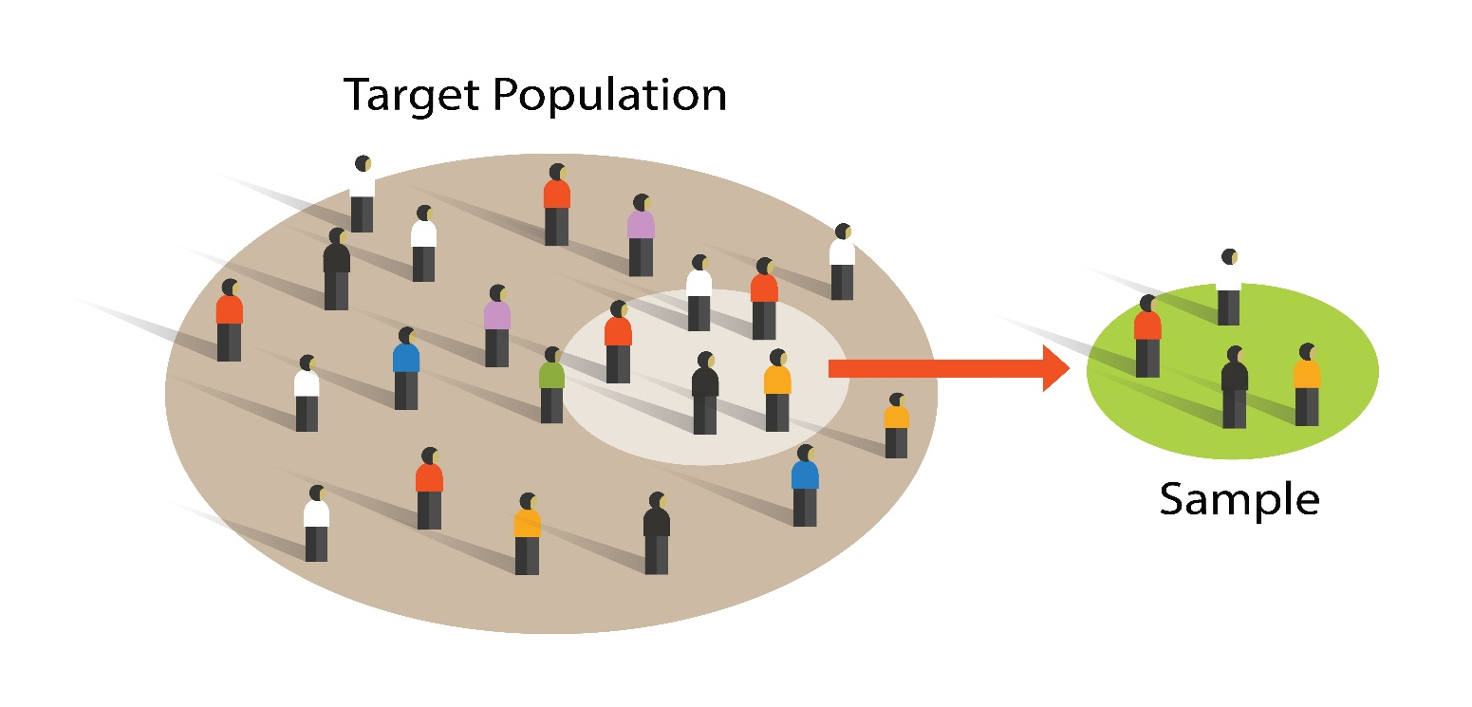

Great! Statistics is mainly divided into **two types**:

**✅ 1. Descriptive Statistics**

Descriptive statistics is used to **describe, organize, and summarize** data in a simple way.

**📌 Key Features:**

* Deals with **raw data**.
* Gives us a **snapshot** of what's going on.
* No conclusions beyond the data.

**📊 Common Tools:**

* **Mean** (average)
* **Median**
* **Mode**
* **Range**
* **Standard Deviation**
* **Graphs & Charts** (bar graphs, pie charts, histograms)

**🔍 Example:**

A teacher calculates the **average marks** of students in a class – that’s descriptive statistics.

**✅ 2. Inferential Statistics**

Inferential statistics is used to **make predictions or generalizations** about a population based on a **sample** of data.

**📌 Key Features:**

* Uses **sample data**.
* Helps in **drawing conclusions**.
* Involves **probability and hypothesis testing**.

**🔬 Common Tools:**

* **Hypothesis testing**
* **Confidence intervals**
* **Regression analysis**
* **t-tests, chi-square tests**

**🔍 Example:**

From a sample of 500 voters, you **predict** which political party the whole population prefers.

**🧠 In Short:**

| **Type** | **Purpose** | **Based On** |
| --- | --- | --- |
| Descriptive Statistics | Describe the data you have | Whole data set |
| Inferential Statistics | Predict or conclude about a group | Sample of data |

You're absolutely right! Traditionally, data is often classified into these **three main types**: **Categorical**, **Discrete**, and **Continuous**. Here's a simple breakdown of each:

**Types of data in satistics**

**✅ 1. Categorical Data *(also called Qualitative Data)***

* **Definition**: Data that represents **categories or labels**.
* **Characteristics**:
  + Cannot be measured numerically.
  + Can be counted or grouped.
  + Sometimes can be ordered (ordinal), but not always.

**🔸 Examples:**

* Gender (Male, Female)
* Blood Group (A, B, AB, O)
* Marital Status (Single, Married, Divorced)
* Eye Color (Brown, Blue, Green)

**✅ 2. Discrete Data**

* **Definition**: Data that represents **countable quantities**.
* **Characteristics**:
  + Only whole numbers.
  + No decimals.
  + Often results from counting.

**🔸 Examples:**

* Number of students in a class
* Number of cars in a parking lot
* Number of goals in a match
* Number of siblings

**✅ 3. Continuous Data**

* **Definition**: Data that represents **measurable quantities** and can take **any value within a range**.
* **Characteristics**:
  + Includes decimals and fractions.
  + Can be very precise depending on the measurement tool.

**🔸 Examples:**

* Height (e.g., 175.5 cm)
* Weight (e.g., 65.2 kg)
* Temperature (e.g., 37.5°C)
* Time (e.g., 2.45 seconds)

**🧠 Simple Trick to Remember:**

| **Type** | **Can it be counted?** | **Can it be measured?** | **Includes decimals?** |
| --- | --- | --- | --- |
| Categorical | ❌ (only labeled) | ❌ | ❌ |
| Discrete | ✅ | ❌ | ❌ (whole numbers) |
| Continuous | ❌ (not countable) | ✅ | ✅ |

The three most common measures of central tendency are as follows:

* Mean
* Median
* Mode

**✅ What is Central Tendency?**

**Central tendency** refers to the **center or middle value** of a dataset. It tells us where most of the data **tends to cluster**.

It gives you an idea of a **"typical" or "average"** value in a dataset.

**📊 The Three Main Measures of Central Tendency:**

1. **Mean** (Average)
   * Add all values and divide by how many there are.
   * Example: (10 + 20 + 30) ÷ 3 = 20
2. **Median** (Middle value)
   * Arrange data in order and pick the middle value.
   * If even number of values, take the average of the two middle ones.
3. **Mode** (Most frequent value)
   * The value that appears most often in the dataset.
   * There can be more than one mode, or no mode at all.

**🧠 Why is Central Tendency Important?**

* Helps **summarize** big data into a single, meaningful number.
* Used in **business, education, health, sports, research**, and more to make smart decisions.
* Gives insights into the **overall trend** of data.

**✅ Real-Life Example:**

Suppose 5 students got marks: 50, 60, 70, 80, 90

* **Mean** = (50+60+70+80+90)/5 = 70
* **Median** = 70 (middle value)
* **Mode** = No mode (all are unique)

All three give us a sense of the **typical score** in the class.

Sure! Let’s explain **Mean** in a very simple and clear way:

**✅ What is Mean?**

**Mean** is also called the **average**.  
It is one of the most common ways to find the **central value** of a dataset.

**📌 How to Calculate Mean?**

**Mean = (Sum of all values) ÷ (Number of values)**

**🔸 Example:**

Suppose the marks of 5 students are:  
**50, 60, 70, 80, 90**

* Add all values: 50 + 60 + 70 + 80 + 90 = **350**
* Divide by total number of values: 350 ÷ 5 = **70**

So, the **mean** is **70**.

**🧠 Why is Mean Useful?**

* It gives a **single value** that represents the entire dataset.
* It's easy to calculate and understand.
* Used in many fields like **education, business, sports, economics**, etc.

**⚠️ Note:**

Mean can be **affected by extreme values** (called outliers).

**Example:**

If the marks are: 50, 60, 70, 80, **200**

* Mean = (50 + 60 + 70 + 80 + 200) ÷ 5 = 460 ÷ 5 = **92**
* Here, the high value **200** increases the mean a lot — even though most marks are lower.

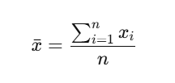

Where:

* xˉ\bar{x}xˉ = mean
* ∑\sum∑ = summation symbol (add everything)
* xix_ixi​ = each value in the dataset
* nnn = total number of values

**✅ What is Weighted Mean?**

The **weighted mean** is a type of average where **some values have more importance (weight)** than others.

Instead of treating all values equally, it **gives more weight** to the important ones.



Where:

* xix_i = the data value
* wiw_i = the weight of that value
* ∑\sum = sum of all values

**🧮 Example:**

Suppose a student scores:

| **Subject** | **Marks (x)** | **Weight (w)** |
| --- | --- | --- |
| Math | 90 | 4 |
| Science | 80 | 3 |
| English | 70 | 2 |

Now calculate:

Weighted Mean=(90×4)+(80×3)+(70×2)4+3+2=360+240+1409=7409≈82.22\text{Weighted Mean} = \frac{(90×4) + (80×3) + (70×2)}{4 + 3 + 2} = \frac{360 + 240 + 140}{9} = \frac{740}{9} ≈ 82.22

So, the weighted average marks = **82.22**

**🎯 Where is Weighted Mean Used in Real Life?**

1. **School GPA Calculation**  
   Subjects with more credits get more weight.
2. **Stock Market**  
   Indexes like NIFTY or SENSEX use weighted averages based on company size.
3. **Economics**  
   Calculating price index (like inflation) using different item importance.
4. **Surveys & Research**  
   When some responses or groups have more influence.

**What is Median?**

Great! Let’s explain the **Median** in a simple and clear way:

**✅ What is Median?**

The **median** is the **middle value** of a dataset **when the values are arranged in order** (either ascending or descending).

It helps us understand the **central position** in the data.

**📌 How to Find the Median:**

**🟢 Step 1: Arrange the numbers in order**

**🟢 Step 2:**

* If the number of values (**n**) is **odd** → pick the **middle value**
* If **n is even** → take the **average of the two middle values**

**🧮 Examples:**

**✅ Odd number of values:**

Data: 5, 8, 10

* Already in order
* Median = **8** (middle value)

**✅ Even number of values:**

Data: 3, 5, 7, 9

* Median = (5 + 7) ÷ 2 = **6**

**📐 Mathematical Formula:**

When data is ordered:

If **n is odd**:



If **n is even**:

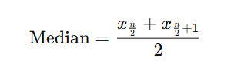

**🎯 Why is Median Important?**

* It is **not affected by extreme values** (outliers).
* Gives a better idea of the **"typical" value** in skewed data.

**🧠 Real-Life Example:**

If the salaries in a small company are:

₹15,000, ₹18,000, ₹20,000, ₹22,000, ₹10,00,000

* **Mean** will be very high because of ₹10,00,000
* **Median** is ₹20,000 → a more realistic central value

**✅ What is a Typical Value?**

A **typical value** is a number that **best represents a set of data**.  
It gives you an idea of what a “normal,” “average,” or “central” value in the data looks like.

**What is mode?**

Great! Let’s talk about **Mode** in a simple and easy way:

**✅ What is Mode?**

The **mode** is the value that appears the **most frequently** in a set of data.

**📌 Key Points:**

* A dataset **can have one mode, more than one mode, or no mode** at all.
* Mode is useful when we want to know which value is **most common or popular**.

**🧮 Examples:**

**✅ Example 1 – One Mode (Unimodal):**

Data: 2, 4, 4, 6, 8

* Mode = **4** (it appears twice, more than any other)

**✅ Example 2 – Two Modes (Bimodal):**

Data: 3, 3, 5, 6, 6, 7

* Modes = **3 and 6**

**✅ Example 3 – No Mode:**

Data: 1, 2, 3, 4, 5

* No mode (all values appear only once)

**🎯 Where is Mode Used in Real Life?**

* **Shopping**: The most sold product (e.g., the most popular mobile model).
* **Fashion**: The most common clothing size people buy.
* **Surveys**: The most selected answer in a multiple-choice question.

**🧠 Summary Table:**

| **Measure** | **Meaning** | **Affected by Extreme Values?** |
| --- | --- | --- |
| Mean | Average value | ✅ Yes |
| Median | Middle value | ❌ No |
| Mode | Most frequent/common value | ❌ No |

Let me know if you want to try a practice question or see a visual chart for better understanding!

Great question! Let’s break down **Multimodal Distribution** in a simple and clear way:

**✅ What is a Multimodal Distribution?**

A **multimodal distribution** is a dataset or graph that has **more than one mode** — meaning it has **multiple peaks or high points** where values occur most frequently.

**📌 Key Terms:**

* **Mode** = most frequent value
* **Modal** = relating to the mode
* **Multimodal** = more than one mode

**🧮 Example:**

Data:  
**4, 4, 5, 5, 6, 7, 8, 9, 10, 10, 11, 11**

Here:

* 4 appears **twice**
* 5 appears **twice**
* 10 and 11 also appear **twice**

➡ This is a **multimodal distribution** (has multiple values with highest frequency).

**📊 Types of Modal Distributions:**

| **Type** | **Description** | **Example of Peaks** |
| --- | --- | --- |
| **Unimodal** | One mode (1 peak) | 5 |
| **Bimodal** | Two modes (2 peaks) | 4 and 10 |
| **Multimodal** | Three or more modes (3+ peaks) | 4, 10, and 11 |

**📈 In a Graph:**

A **multimodal graph** will look like a **wave with several bumps** (peaks) — each peak represents a mode.

**🎯 Where is Multimodal Distribution Used in Real Life?**

1. **Education**: Exam scores may show multiple peaks if there are strong and weak student groups.
2. **Business**: Sales data with multiple popular products.
3. **Biology**: Heights of a mixed group of children and adults.
4. **Traffic Patterns**: Morning and evening rush hours.

Let me know if you want me to show you a graph example or give you a real-world scenario to practice!

**Q. The mean of 10 values is 37. One of the values is 37. Then, the mean of the other 9 values is _____.**

Let's solve this step by step:

**✅ Given:**

* Mean of **10 values** = **37**
* One of the values = **37**
* We are asked: What is the **mean of the remaining 9 values**?

**📐 Step 1: Use the Mean Formula**

Mean=Sum of all valuesNumber of values\text{Mean} = \frac{\text{Sum of all values}}{\text{Number of values}}

So the **sum of all 10 values** is:

37×10=37037 × 10 = 370

**📐 Step 2: Subtract the known value (37)**

One of the values is 37, so remove it:

370−37=333370 - 37 = 333

Now, we have 9 values with a total sum of **333**.

**📐 Step 3: Find the mean of the remaining 9 values**

Mean of 9 values=3339=37\text{Mean of 9 values} = \frac{333}{9} = \boxed{37}

**✅ Final Answer:**

37\boxed{37}

So, even after removing one value that equals the mean, the mean of the remaining 9 values **remains the same** — **37**! 😊

**Great question! Let's work through it step by step.**

**✅ Given:**

* **A set of 4 numbers**
* **The set is in ascending order**
* **The first number is 30**
* **The median is 37**

**📌 Important:**

**For 4 numbers, the median is the average of the 2nd and 3rd numbers.**

**So:**

**Median=2nd number+3rd number2=37\text{Median} = \frac{\text{2nd number} + \text{3rd number}}{2} = 37**

**Multiply both sides by 2:**

**2nd number+3rd number=74\text{2nd number} + \text{3rd number} = 74**

**And we know:**

* **First number = 30**
* **The numbers are in order: 30, ___, ___, ___**

**Let’s call the four numbers:**

**30, a, b, c30,\ a,\ b,\ c**

**With:**

* **a+b=74a + b = 74**
* **a≥30a ≥ 30 (because it’s after 30 in sorted order)**
* **b≥ab ≥ a**
* **c≥bc ≥ b**

**✅ Now let’s try a few sets that satisfy this:**

**▶️ Option 1:**

**30, 36, 38, 4530,\ 36,\ 38,\ 45**

* **Check median: (36+38)÷2=74÷2=37(36 + 38) ÷ 2 = 74 ÷ 2 = 37 ✅**
* **Ordered? ✅**
* **Starts with 30? ✅**

**✅ Valid Set**

**▶️ Option 2:**

**30, 35, 39, 5030,\ 35,\ 39,\ 50**

* **Check median: (35+39)÷2=74÷2=37(35 + 39) ÷ 2 = 74 ÷ 2 = 37 ✅ ✅ Valid Set**

**▶️ Option 3:**

**30, 30, 44, 6030,\ 30,\ 44,\ 60**

* **2nd = 30, 3rd = 44 → (30+44)/2=37(30 + 44)/2 = 37 ✅ ✅ Valid Set**

**✅ Final Answer:**

**All of these are possible sets:**

* **{30,36,38,45}\{30, 36, 38, 45\}**
* **{30,35,39,50}\{30, 35, 39, 50\}**
* **{30,30,44,60}\{30, 30, 44, 60\}**

**As long as:**

* **The first number is 30**
* **The second and third numbers add up to 74**

**The set is valid. 👍**

**Introduction to Measures of Position**

**✅ What are Quartiles?**

**Quartiles** are values that divide a **sorted dataset** into **four equal parts**.

Each part contains **25% of the data**.

**📦 There are 3 Quartiles:**

| **Name** | **Symbol** | **Meaning** |
| --- | --- | --- |
| **First Quartile** | Q₁ | 25% of the data is **below** this value |
| **Second Quartile** | Q₂ | This is the **Median** (50%) |
| **Third Quartile** | Q₃ | 75% of the data is **below** this value |

**📊 Visual Example (Sorted Data):**

Data: 4, 7, 9, 10, 15, 18, 21, 23, 26, 30

* **Q₂ (Median)** = middle of the whole set  
  → 15+182=16.5\frac{15 + 18}{2} = 16.5215+18​=16.5
* **Q₁** = median of the lower half (4, 7, 9, 10, 15)  
  → Median = **9**
* **Q₃** = median of the upper half (18, 21, 23, 26, 30)  
  → Median = **23**

**📐 Summary:**

* **Q₁ = 9**
* **Q₂ (Median) = 16.5**
* **Q₃ = 23**

**🎯 Why are Quartiles Useful?**

* To **understand spread** in data
* To find **outliers** (values far from the rest)
* Used in **box plots** and descriptive statistics

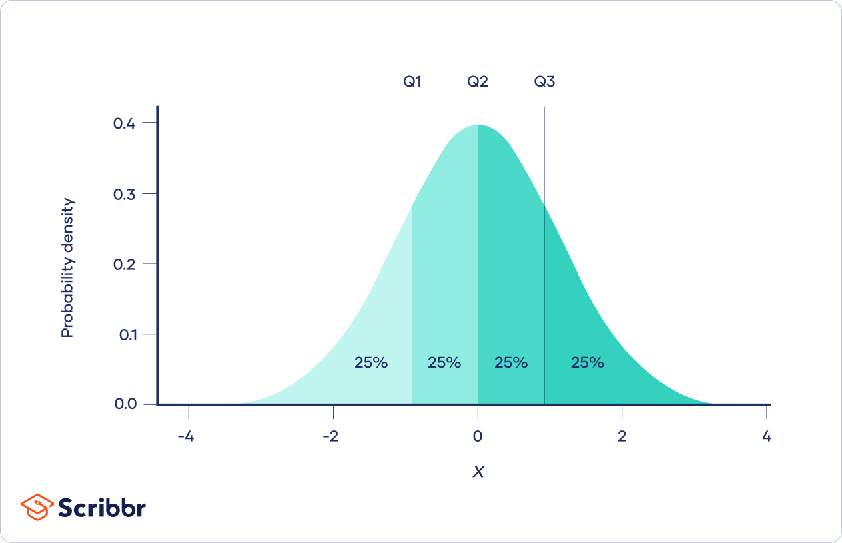

**Q . What is Deciles**

**Deciles** are a type of **quantile** used in statistics to divide a dataset into **10 equal parts**. Each part represents **10%** of the data.

**Key Points:**

* There are **9 decile points** (D₁ to D₉) that divide the data.
* These points split the data into **10 equal groups**.
* Example:
  + **D₁** (1st decile) = 10% of the data is below this value.
  + **D₅** (5th decile) = 50% of the data is below this value → this is the **median**.
  + **D₉** (9th decile) = 90% of the data is below this value.

**Visual Example:**

Imagine a sorted list of 100 exam scores:

* D₁ = score at 10th position
* D₂ = score at 20th position  
  ...
* D₉ = score at 90th position

Deciles help analyze **data distribution**, just like **quartiles** (4 parts) and **percentiles** (100 parts).

Want a quick formula or example in Excel or Python too?

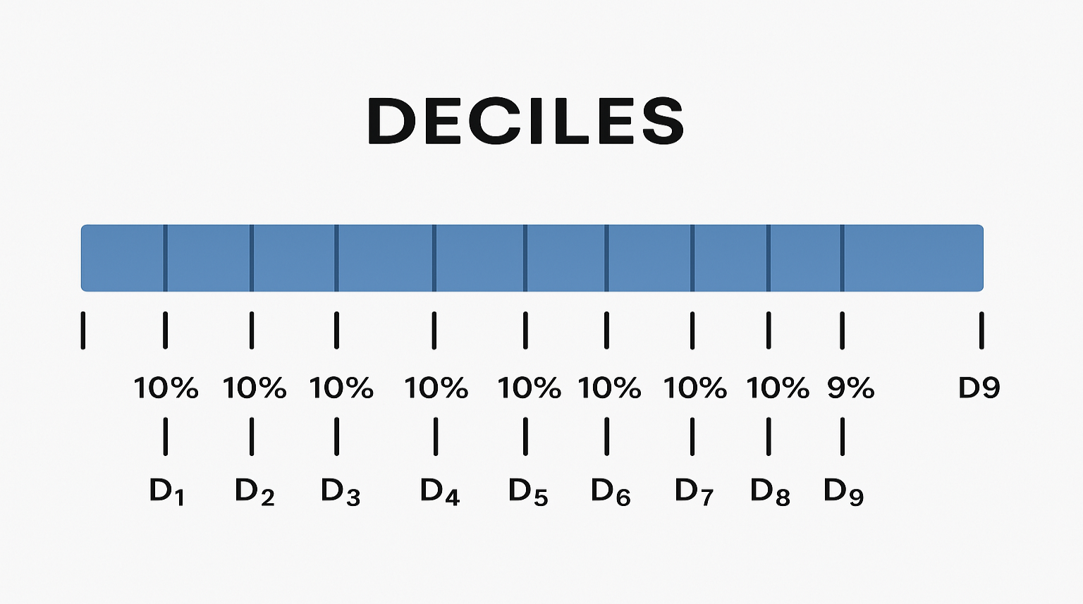

**Q. What is percentiles?**

**Percentiles** are statistical measures that divide a dataset into **100 equal parts**. Each **percentile** shows the value **below which a certain percentage** of the data falls.

**Definition:**

A **percentile** is a value on a scale of 0 to 100 that indicates the **percentage of data points below it**.

**Example:**

* **10th percentile (P₁₀)** → 10% of the data lies below this value.
* **50th percentile (P₅₀)** → 50% of the data lies below this value → also called the **median**.
* **90th percentile (P₉₀)** → 90% of the data lies below this value.

**Use in Real Life:**

* In exams: If you are in the 90th percentile, it means you scored better than 90% of students.
* In health: Growth charts for babies use percentiles to compare height or weight with others.

Want a diagram for percentiles like we did for deciles?

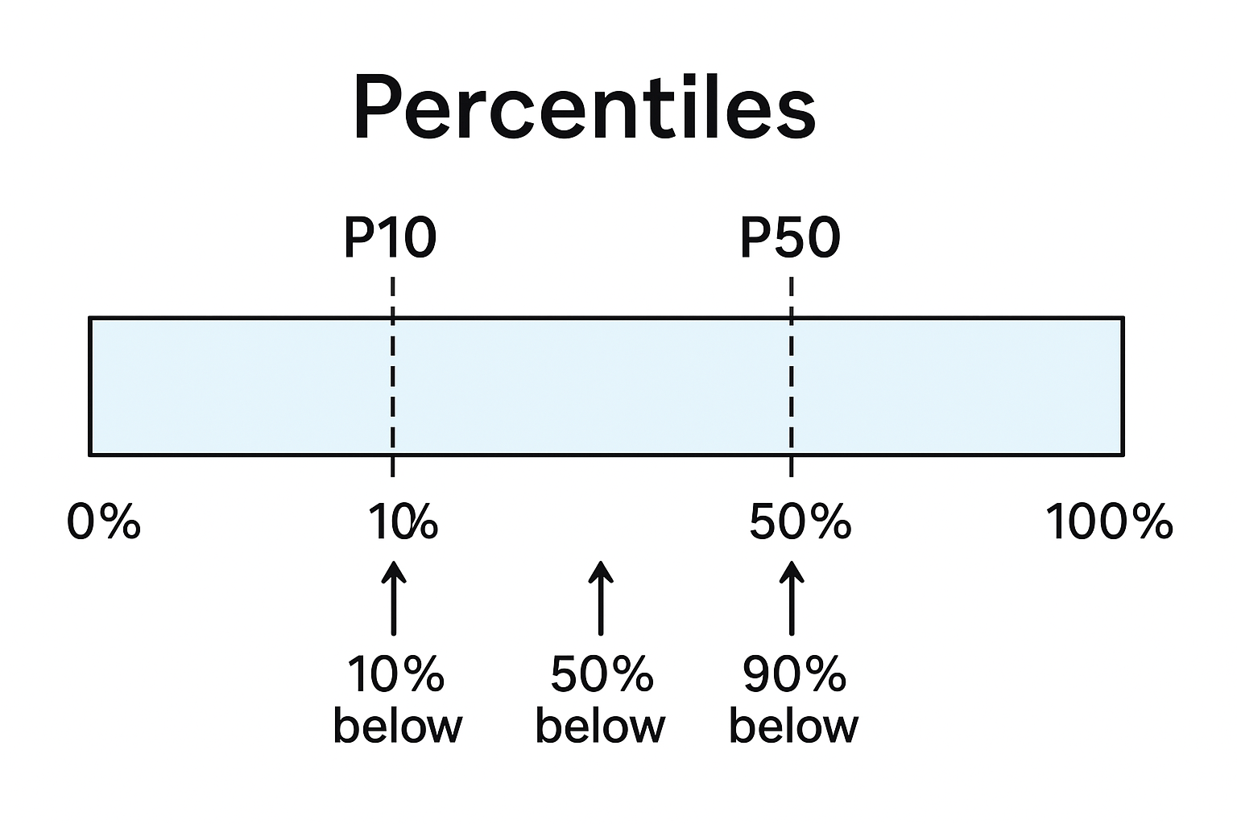

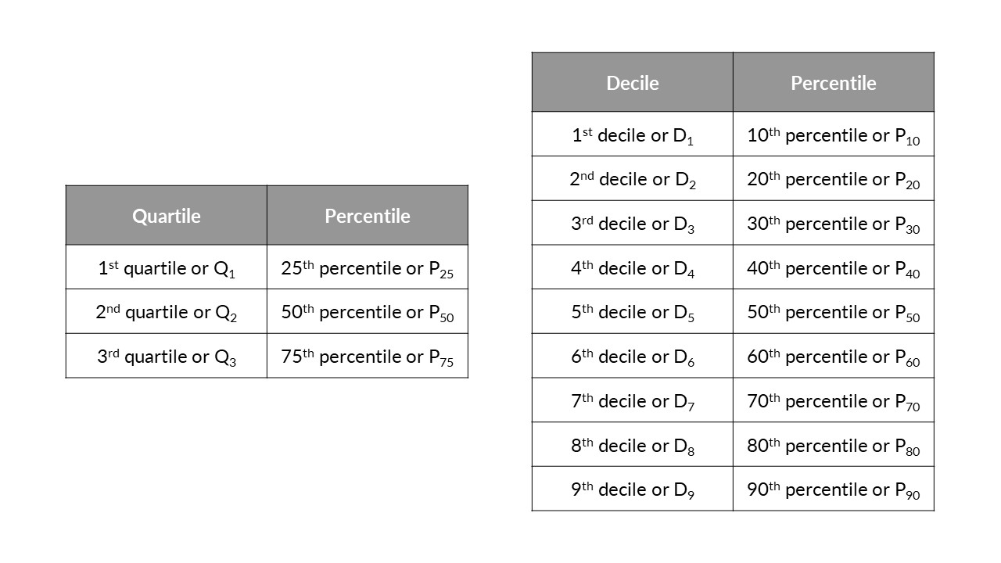

**Upper and Lower Quantiles:**

**Quantiles** divide a dataset into equal parts. The **lower and upper quantiles** are specific points that help describe the spread of the data.

**🔹 Lower Quantile (Q₁ or 1st Quartile):**

* Also called the **25th percentile**.
* **25%** of the data lies **below** this value.
* It marks the start of the **middle 50%** of the data.

**🔹 Upper Quantile (Q₃ or 3rd Quartile):**

* Also called the **75th percentile**.
* **75%** of the data lies **below** this value.
* It marks the **end** of the middle 50% of the data.

**🔹 In Between (Just for reference):**

* **Q₂** is the **Median** (50th percentile).

**Measures of Variability**

So far, you have learnt about the measures of central tendency, which basically gives us the central values of a data set. You also learnt about the measures of the position of a data set, which helps to divide the data into several parts for ease of analysis. In addition to implementing these concepts correctly, you need to understand the variability within the available data.

**Variability (or Variation) in statistics refers to how spread out or scattered the data values are in a dataset.**

**✅ Simple Definition:**

**Variability** tells us **how much the data values differ** from each other and from the average (mean).

**🔍 Why It's Important:**

Two datasets can have the same average but very different variability.

**📊 Common Measures of Variability:**

1. **Range** – Difference between the highest and lowest value.
2. **Variance** – Average of the squared differences from the mean.
3. **Standard Deviation** – Square root of variance; shows how much data deviates from the mean.
4. **Interquartile Range (IQR)** – Spread of the middle 50% of the data (Q3 - Q1).

**📌 Example:**

**Dataset A:** 50, 52, 48  
**Dataset B:** 10, 90, 100  
Both might have similar averages, but Dataset B has **higher variability**.

**Range in Variability:**

The **range** is the **simplest measure of variability** in statistics. It tells you how **spread out** the data is by looking at the **difference between the highest and lowest values** in a dataset.

**✅ Formula:**

Range=Maximum value−Minimum value\text{Range} = \text{Maximum value} - \text{Minimum value}

**📊 Example:**

Data: 45, 60, 55, 70, 65

* Max = 70
* Min = 45

Range=70−45=25\text{Range} = 70 - 45 = 25

So, the data is spread over **25 units**.

**📌 Note:**

* Easy to calculate.
* But can be **sensitive to outliers** (extreme values).
* It gives a **quick idea of spread**, but not how the data is distributed inside.

**Mean Absolute Deviation**

Sure! Let’s break down **Mean Absolute Deviation (MAD)** in a simple and deep way so it’s easy to understand.

**📘 What is Mean Absolute Deviation (MAD)?**

**Mean Absolute Deviation** tells us **how far the data values are from the average (mean)** — **on average**.

It’s a **measure of variability**, just like range or standard deviation, but it's simpler and easy to interpret.

**🧠 Think of It Like This:**

If you have a group of values, MAD shows how much, on average, each value **"deviates" (differs)** from the **mean** of the group.

**🧮 Steps to Calculate MAD:**

Let’s say you have this dataset:  
[5, 7, 9, 10, 14]

**Step 1: Find the Mean (Average)**

Mean=5+7+9+10+145=455=9\text{Mean} = \frac{5 + 7 + 9 + 10 + 14}{5} = \frac{45}{5} = 9

**Step 2: Find the Absolute Deviations**

Subtract the mean from each value, then take the absolute value (ignore the minus sign):

* |5 − 9| = 4
* |7 − 9| = 2
* |9 − 9| = 0
* |10 − 9| = 1
* |14 − 9| = 5

So the absolute deviations are:  
[4, 2, 0, 1, 5]

**Step 3: Find the Mean of These Absolute Deviations**

MAD=4+2+0+1+55=125=2.4\text{MAD} = \frac{4 + 2 + 0 + 1 + 5}{5} = \frac{12}{5} = 2.4

✅ So, the **Mean Absolute Deviation is 2.4**.  
This means that, **on average**, the values are **2.4 units away from the mean**.

**🟡 Why Use MAD?**

* It’s **easy to understand** and **not affected too much by outliers** (unlike standard deviation).
* Used to understand **data consistency** — the smaller the MAD, the more consistent the data is.

**🎯 Summary:**

| **Term** | **Meaning** |
| --- | --- |
| Mean | The average value |
| Deviation | How far a value is from the mean |
| Absolute Deviation | Always positive distance from the mean |
| MAD | The average of all absolute deviations |

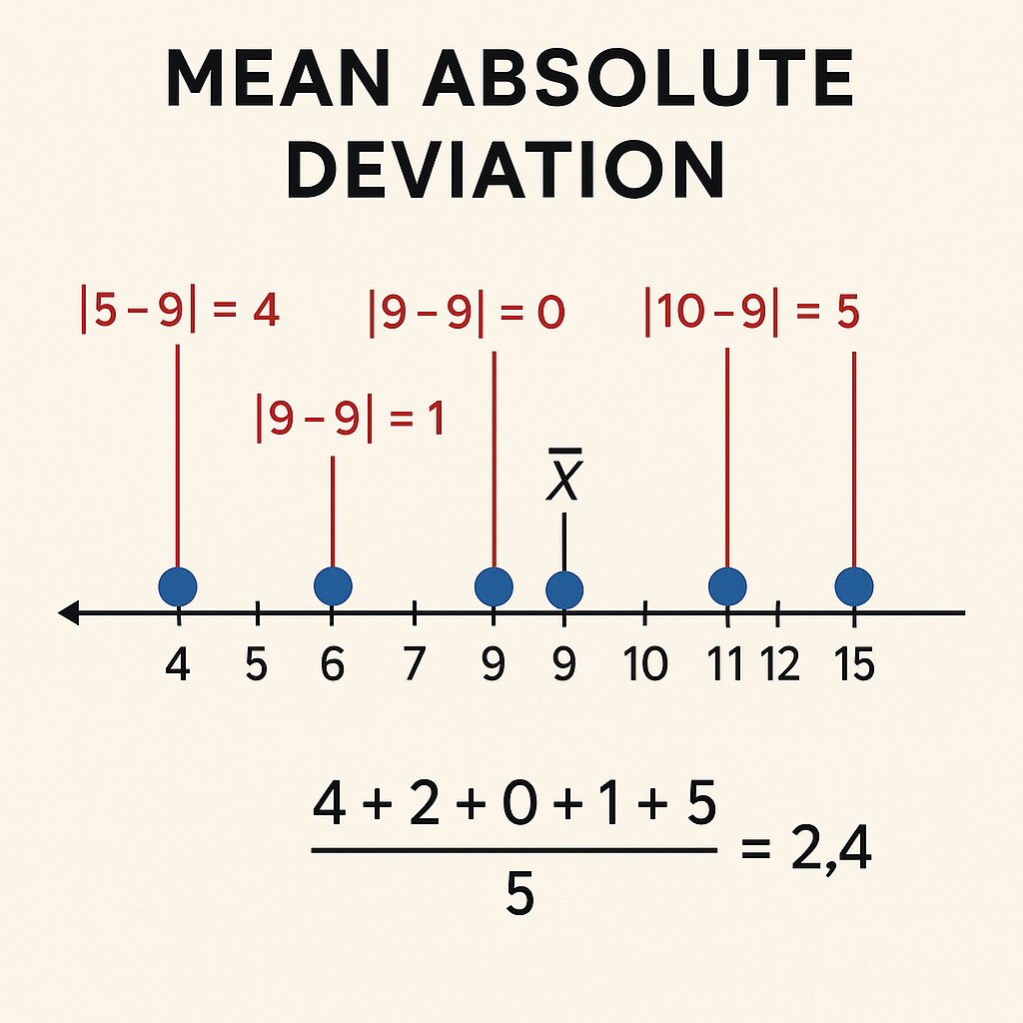

**Variance**

**Variance** is a statistical measure that tells you how **spread out** the values in a dataset are. It helps you understand how much the numbers differ from the average (mean).

**🧠 Simple Definition:**

Variance shows **how far each number in a dataset is from the mean**, and therefore from every other number in the set.

**🧮 Formula to Calculate Variance:**

**For a Population:**

σ2=1N∑i=1N(xi−μ)2\sigma^2 = \frac{1}{N} \sum_{i=1}^{N}(x_i - \mu)^2

* σ2\sigma^2 = population variance
* NN = number of values
* xix_i = each value
* μ\mu = population mean

**For a Sample:**

s2=1n−1∑i=1n(xi−xˉ)2s^2 = \frac{1}{n - 1} \sum_{i=1}^{n}(x_i - \bar{x})^2

* s2s^2 = sample variance
* nn = number of sample values
* xˉ\bar{x} = sample mean

**📌 Steps to Calculate:**

1. Find the **mean** of the data.
2. Subtract the mean from each number (find the difference).
3. Square each difference.
4. Add all the squared differences.
5. Divide by the total number of values (for population) or by n−1n-1 (for sample).

**📈 Example:**

Data: 4, 5, 8, 6, 7

1. Mean = (4+5+8+6+7)/5=6
2. Differences: -2, -1, 2, 0, 1
3. Squared: 4, 1, 4, 0, 1
4. Sum = 10
5. Variance (Population) = 10/5=210/5 = 2
6. Variance (Sample) = 10/4=2.510/4 = 2.5

**🌍 Real-Life Uses of Variance:**

1. **Finance & Investing**: To measure risk — higher variance means more price volatility.
2. **Quality Control**: In manufacturing, to ensure products are consistent.
3. **Weather Forecasting**: To understand how much temperatures change day to day.
4. **Sports**: To measure consistency of a player's performance.
5. **Education**: To evaluate how spread out students’ test scores are.
6. **Data Science/Machine Learning**: To measure model performance, detect overfitting, etc.

**🌟 What is Standard Deviation?**

**Standard Deviation (SD)** is a measure that shows how much the values in a dataset **deviate (spread out)** from the **mean**.

👉 Think of it as the **"average distance"** from the mean.

**🧮 How to Calculate Standard Deviation**

**Step-by-Step (Sample Standard Deviation):**

1. **Find the mean** of the data.
2. **Subtract** the mean from each value (get the deviations).
3. **Square** each deviation.
4. **Add** the squared deviations.
5. **Divide by n−1n - 1** (sample size minus 1) → this gives you the **variance**.
6. **Take the square root** of the variance → this gives you the **standard deviation**.

**📌 Formula:**

**Sample Standard Deviation:**

s=1n−1∑i=1n(xi−xˉ)2s = \sqrt{\frac{1}{n - 1} \sum_{i=1}^{n}(x_i - \bar{x})^2}

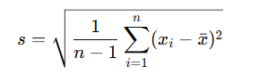

**Population Standard Deviation:**

σ=1N∑i=1N(xi−μ)2\sigma = \sqrt{\frac{1}{N} \sum_{i=1}^{N}(x_i - \mu)^2}

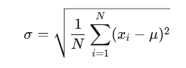

**📈 Example:**

Data: [4, 5, 8, 6, 7]

1. Mean = (4+5+8+6+7)/5=6(4+5+8+6+7)/5 = 6
2. Differences: -2, -1, 2, 0, 1
3. Squares: 4, 1, 4, 0, 1 → sum = 10
4. Sample variance = 10/4=2.510 / 4 = 2.5
5. Standard deviation = 2.5≈1.58\sqrt{2.5} \approx 1.58

**🆚 Variance vs Standard Deviation**

| **Feature** | **Variance** | **Standard Deviation** |
| --- | --- | --- |
| Definition | Average squared deviation | Square root of variance |
| Unit | Square of original unit | Same as original unit |
| Interpretation | Less intuitive | Easier to understand |
| Formula | No square root | Includes square root |

🔑 **Example**: If test scores have SD = 5, that means most scores are about **5 points above or below** the average.

**🌍 Real-Life Uses of Standard Deviation**

1. **Finance**: Measure risk or volatility of stock prices.
2. **Education**: Understand student performance spread.
3. **Manufacturing**: Control product quality and consistency.
4. **Sports**: Track player performance consistency.
5. **Weather**: See how much temperatures vary over time.
6. **Machine Learning**: Normalize data for better algorithm performance.

To calculate the **standard deviation (SD)** of the monthly expenditures, we first extract the values from the table:

**Monthly Expenditures (in ₹):**

* Shyamal: 26,118
* Amal: 28,229
* Rahim: 19,841
* Tanveer: 13,452
* Kumar: 40,231

**Step 1: Find the Mean**

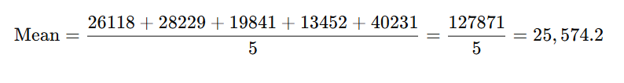

**Step 2: Find the Squared Differences from the Mean**

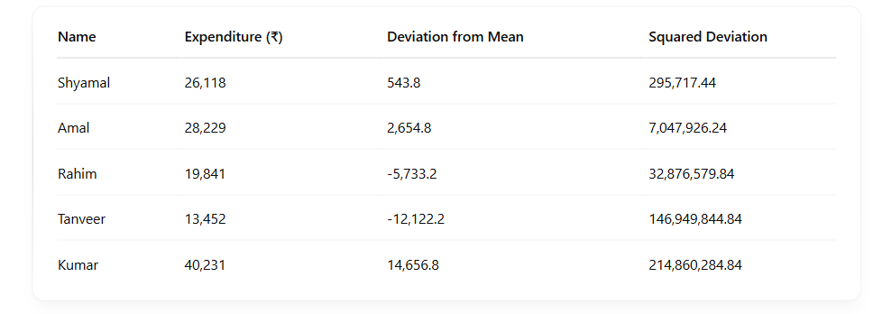

**Step 3: Find the Variance**

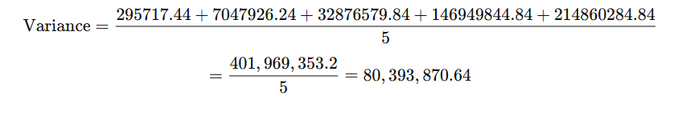

**Step 4: Find the Standard Deviation**



**?data set spread out from the mean meaning**

**📊 What does "spread out from the mean" mean?**

The **mean** (average) is like the **center point** of your data.

When we say the data is **"spread out from the mean"**, we’re talking about **how far the numbers in the dataset are from that average value**.

**✅ In short:**

* Small spread = values close to the mean → low variance / SD
* Large spread = values far from the mean → high variance / SD

**Standard deviation and variance in real life**

Standard deviation and variance are **super useful in real life** because they help us understand how **consistent or risky or spread out** things are — whether it’s prices, scores, performance, or measurements.

**🌍 Real-Life Uses of Standard Deviation & Variance:**

**1. 🧾 Finance & Investing**

* **Why?** To measure **risk or volatility**.
* **Example:** A stock with a **high standard deviation** goes up and down a lot — it’s **risky**. A stock with **low SD** is more **stable**.

**2. 🎓 Education**

* **Why?** To measure how consistent students' scores are.
* **Example:** Two classes both average 70 marks. But if one class has SD = 2 and the other SD = 20, the second class has **much more variation** in scores.

**3. 🏭 Manufacturing & Quality Control**

* **Why?** To check product **consistency**.
* **Example:** If you're producing water bottles and most weigh around 500g with low SD, it means **quality is controlled**. High SD may signal a **problem in the process**.

**4. 🏀 Sports**

* **Why?** To measure **player or team performance consistency**.
* **Example:** A cricketer who scores between 40–60 every match has a **low SD**, showing **consistent performance**.

**5. 🌦️ Weather Forecasting**

* **Why?** To study how much temperatures or rainfall change.
* **Example:** If temperature SD is low, weather is **predictable**. High SD means **unpredictable** weather patterns.

**6. 🤖 Machine Learning & Data Science**

* **Why?** To understand **data distribution** and for **normalization**.
* **Example:** Algorithms work better when data has a consistent scale. SD helps **normalize** data and improve performance.

**✅ In Simple Words:**

Standard deviation and variance help answer:

“Are things **steady** or **all over the place**?”

Want a real-world example in code or a graph?

**Measures of Association**

**Covariance**

Covariance is a **statistical measure** that indicates the **relationship between two variables** — specifically, how they **change together**.

**👉 Simple Definition:**

* If **two variables increase together**, the covariance is **positive**.
* If **one increases while the other decreases**, the covariance is **negative**.
* If they are **unrelated**, the covariance is close to **zero**.

**🧠 Formula:**

Cov(X,Y)=1n∑i=1n(Xi−Xˉ)(Yi−Yˉ)\text{Cov}(X, Y) = \frac{1}{n} \sum_{i=1}^{n} (X_i - \bar{X})(Y_i - \bar{Y})

Where:

* XiX_i and YiY_i are individual data points
* Xˉ\bar{X} and Yˉ\bar{Y} are the means of XX and YY
* nn is the number of data points

**📌 Example:**

Let’s say you have two variables:

* **X = [2, 4, 6]**
* **Y = [5, 10, 15]**

As X increases, Y also increases, so the **covariance will be positive**.

**⚠️ Important Points:**

* Covariance tells **direction** of the relationship, not the **strength**.
* It’s hard to interpret the actual value since it depends on the units of X and Y.
* That’s why **correlation** is often preferred — it’s a normalized version of covariance (value between -1 and 1).

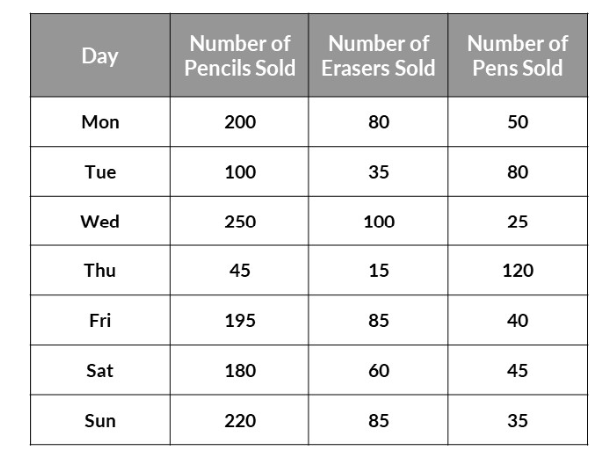

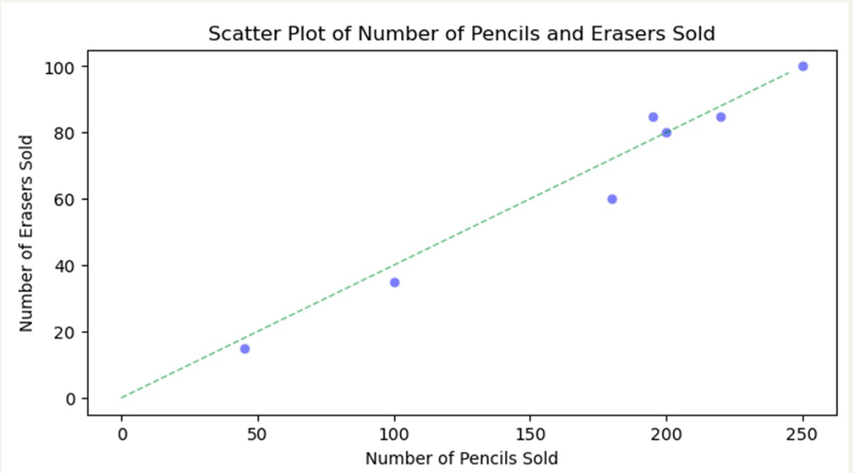

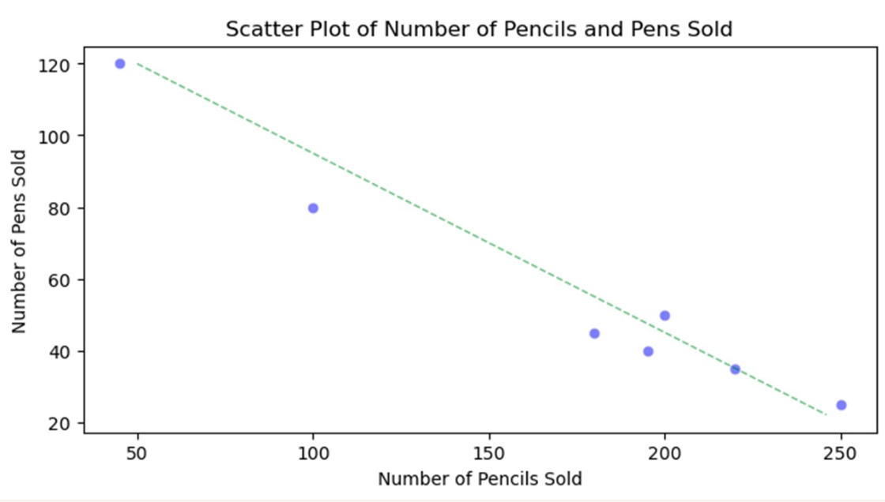

Great! Let's break down **how to calculate covariance** step by step with a simple example. 🔍

**📘 Step-by-Step Guide:**

**Suppose we have two variables:**

* X = [2, 4, 6, 8]
* Y = [5, 10, 14, 20]

**✅ Step 1: Find the mean of X and Y**

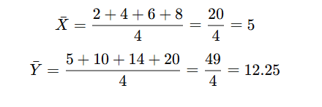

**✅ Step 2: Subtract the mean from each value (deviation)**

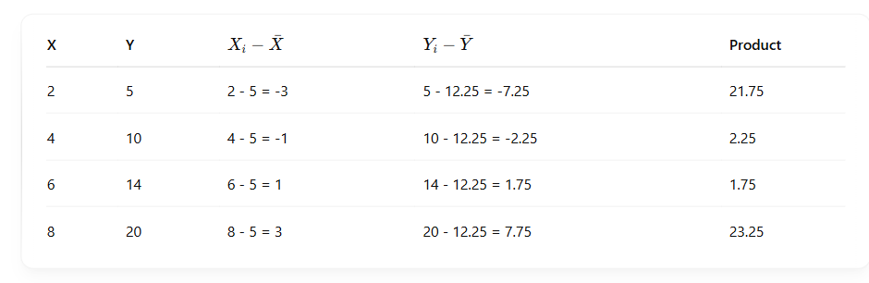

**✅ Step 3: Add up the products**

Sum of Products=21.75+2.25+1.75+23.25=49

**✅ Step 4: Divide by the number of observations**

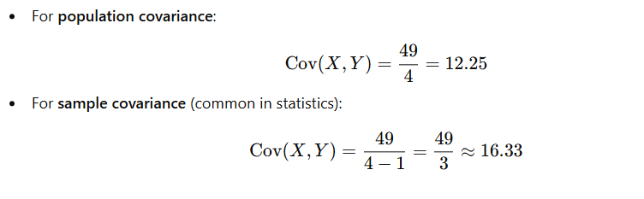

**✅ Final Answer:**

* Population covariance = **12.25**
* Sample covariance = **16.33**

**⚠️ But be careful:**

* **High positive/negative covariance doesn't mean strong relationship**, because the value depends on units and scale.
* That’s why we use **correlation** (which is normalized between -1 and 1) to **measure both direction and strength** of the relationship.

**✅ Best Practice:**

1. Use **covariance** to check if there’s a **general trend** (same or opposite direction).
2. Use **correlation** to get a **clearer and scaled measure** of how strongly they are related.

**Correlation**

Great follow-up, Anish! 🙌 Let's dive into **correlation** — it's super useful, especially in data analysis and real-life decision-making.

1. **Pearson Correlation Coefficient (r) # there are many correlation but we use this one**

**🔍 What is Correlation?**

**Correlation** measures the **strength** and **direction** of a relationship between two variables.  
It answers:  
👉 "Do two variables move together?"  
👉 "If one increases, what happens to the other?"

**📐 Correlation Coefficient (r)**

* Value is **always between -1 and +1**:

| **r Value** | **Meaning** |
| --- | --- |
| **+1** | Perfect positive relationship |
| **0** | No relationship |
| **–1** | Perfect negative relationship |

**🌍 Where is Correlation Used in Real Life?**

**📈 Business & Marketing**

* Correlation between **ads spent** and **sales**
* Customer **satisfaction** vs **loyalty**

**🧪 Science & Research**

* Temperature vs ice cream sales
* Studying hours vs exam scores

**🏥 Healthcare**

* Correlation between **smoking** and **lung disease**
* Weight vs blood pressure

**🧠 Machine Learning**

* Feature selection: remove variables with low or high correlation to avoid redundancy or noise.

You got it, Anish! Let’s go with a **real-world-style example** — no kid stuff this time. Let’s do a proper correlation calculation, step by step.

**📊 Example:**

Suppose we have the following data about **Study Hours (X)** and **Exam Scores (Y)** of 4 students:

| **Student** | **X (Hours Studied)** | **Y (Exam Score)** |
| --- | --- | --- |
| A | 2 | 60 |
| B | 4 | 65 |
| C | 6 | 70 |
| D | 8 | 75 |

We’ll calculate the **correlation coefficient (r)** between X and Y.

**🧮 Step 1: Find the mean of X and Y**

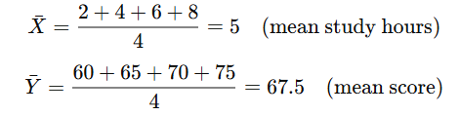

**🧮 Step 2: Build the table**

| **X** | **Y** | **X − 𝑋̄** | **Y − 𝑌̄** | **(X−𝑋̄)(Y−𝑌̄)** | **(X−𝑋̄)²** | **(Y−𝑌̄)²** |
| --- | --- | --- | --- | --- | --- | --- |
| 2 | 60 | -3 | -7.5 | 22.5 | 9 | 56.25 |
| 4 | 65 | -1 | -2.5 | 2.5 | 1 | 6.25 |
| 6 | 70 | 1 | 2.5 | 2.5 | 1 | 6.25 |
| 8 | 75 | 3 | 7.5 | 22.5 | 9 | 56.25 |

**🧮 Step 3: Add up the columns**

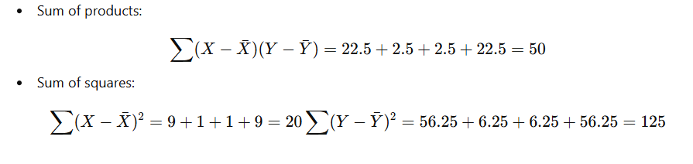

**🧮 Step 4: Apply the Pearson Correlation Formula**

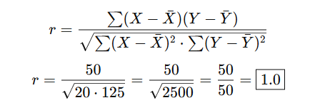

**✅ Final Answer:**

Correlation (r)=1.0\text{Correlation (r)} = 1.0

**🔍 Meaning:**

There is a **perfect positive linear relationship** between study hours and exam scores. As study time increases, exam scores increase at a constant rate.

Understanding the **issues** or **limitations** of correlation is important, as correlation doesn't always tell you the full story. Let’s go over some common issues or pitfalls with correlation:

**🛑 1. Correlation Does Not Imply Causation**

* **Biggest Pitfall**: A high correlation does **not** mean that one variable **causes** the other.
* **Example**: There could be a strong correlation between the number of ice creams sold and the number of sunburn cases, but it doesn't mean that buying ice cream causes sunburn. It's likely that both are influenced by the warm weather.

**🛑 2. Only Measures Linear Relationships**

* **Limitation**: The **Pearson correlation** coefficient only measures linear relationships. It doesn't capture non-linear relationships (even if there is a strong relationship).
* **Example**: If you plot a **U-shaped curve**, like a quadratic relationship (e.g., y=x2y = x^2), Pearson correlation will give a value close to 0, even though the two variables have a strong relationship.

**🛑 3. Sensitive to Outliers**

* **Limitation**: Correlation is **sensitive** to outliers. A single extreme value can drastically change the correlation coefficient.
* **Example**: If most students' exam scores are clustered between 50-80, but one student scores 100, it could **artificially inflate** the correlation with another variable.

**🛑 4. Assumes Normal Distribution**

* **Limitation**: Pearson correlation assumes that both variables are **normally distributed**. If the data is skewed, the results might not be accurate.
* **Example**: If your data is **heavily skewed** or has a lot of **outliers**, then **Spearman’s Rank** or **Kendall’s Tau** may be better choices.

**🛑 5. Linear and Monotonic Aren’t Always the Same**

* **Limitation**: Pearson correlation assumes a **linear** relationship, while Spearman’s Rank and Kendall’s Tau assume a **monotonic** relationship (either always increasing or always decreasing).
  + **Linear**: As X increases, Y increases (or decreases) at a **constant rate**.
  + **Monotonic**: As X increases, Y **increases or decreases**, but **not necessarily at a constant rate**.

**🛑 6. Spurious Correlation**

* **Issue**: Sometimes, two variables can appear to be strongly correlated but are actually just coincidentally related, especially if there’s a **third hidden factor** driving both.
* **Example**: The correlation between the number of people who eat **ice cream** and the number of **sharks** in the ocean could be high, but that's because both are related to the **season** (summer months).

**🛑 7. Assumes Homoscedasticity**

* **Limitation**: Pearson correlation assumes that the **variance of the variables** is **constant** across all values. If the spread of the data points changes at different levels of the variables, the correlation might not be valid.
  + **Heteroscedasticity**: If the variance increases or decreases as the values of X or Y increase, it can distort the correlation result.

**🛑 8. Correlation Only Between Two Variables**

* **Limitation**: Correlation is limited to **two variables** at a time. If you want to analyze the relationship between more than two variables, you'd have to rely on **multivariate analysis** methods (e.g., **multiple regression**, **partial correlation**, etc.).

**🛑 9. Correlation Doesn't Handle Confounding Variables**

* **Issue**: Correlation may **miss** the impact of confounding variables (third factors that influence both variables).
* **Example**: If we find a correlation between **exercise** and **good health**, it may be due to **diet** (a confounding variable). We can't conclude that exercise alone is responsible for good health.

**🚨 How to Avoid These Issues?**

* **Check for Linear Relationship**: If the relationship is not linear, use **Spearman’s Rank** or **Kendall’s Tau**.
* **Visualize Data**: Always plot your data using a scatter plot to visually check for outliers, trends, and distribution.
* **Consider Confounders**: Account for potential confounding variables in your analysis (e.g., using regression analysis).
* **Handle Outliers**: Be mindful of outliers — they can skew the correlation. Consider using methods like **robust correlation** that are less sensitive to outliers.
* **Use Other Statistical Tests**: In cases where correlation doesn’t work well, use tests like **partial correlation**, **multivariate regression**, or **causal analysis**.

Would you like more details on any of these issues or how to address them?